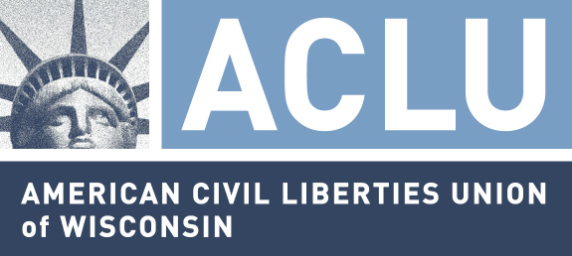
207 E. Buffalo Street, #325
Milwaukee, WI 53202-5774

MEDIA RELEASE

For Immediate Release: October 9, 2009

Contact: Christopher Ahmuty, Executive Director, (414) 272-4032, ext. 13

DNA collection expansion too costly, too invasive, and too distracting,
ACLU of Wisconsin Says

Milwaukee – The American Civil Liberties Union of Wisconsin today urged state lawmakers to oppose legislation that would expand profiles in the state DNA data bank to include individuals merely arrested, not convicted, on a felony charge. State Senator Sheila Harsdorf (R-River Falls) and State Representative Ann Hraychuck (D-Balsam Lake) are co-sponsors of Senate Bill 336, which has been referred to the Senate Judiciary Committee.

Christopher Ahmuty, Executive Director of the ACLU of Wisconsin, issued the following statement:

DNA technology has great potential for addressing crime, but we must use it and any developing technology wisely. When police are looking for a needle in a haystack, we shouldn’t be adding more hay to the stack. But that's exactly what SB336 does by collecting and analyzing DNA samples from individuals who have not been convicted of a violent crime.

While it is clear that the Wisconsin State Crime Laboratories’ DNA data bank system needs better management, a dramatic expansion of DNA collection without adequate checks and balances and funding at a time when the State and its counties have serious funding problems is like throwing water on a drowning swimmer.

This proposal allows the state crime laboratories to maintain the DNA profiles of persons who are never charged for as long as a year. During that year the DNA profile is likely to be shared with the federal DNA data bank (CODIS) making it virtually impossible to remove it from state, federal and even international DNA data banks. DNA collection is an invasive search that jeopardizes the constitutional rights of Americans, if it is not done judiciously.

Expanding DNA collection to arrestees has undermined the use of DNA to solve crimes across the nation. In March, the Inspector General at the United State Department of Justice released an audit that found that state laws expanding DNA collection have led to significant delays in DNA analysis. Audits in Illinois and Michigan have similarly found massive backlogs due to increased DNA collection.

And in Milwaukee, recent media reports reveal that the Sheriff David Clarke’s own department failed to collect DNA samples from over 350 convicted felons this year at the County Correctional Facility – South.

Finally, expanding DNA collection will perpetuate, if not increase, the racial disparities that are acknowledged to exist in Wisconsin’s criminal justice system. When a disproportionate number of minorities are arrested, they will create unwarranted racial disparities in the DNA data bank, making them permanent suspects who need to be investigated, while white perpetrators may not even be in the data bank.

The ACLU of Wisconsin urges legislators to re-direct their efforts to improve the state’s DNA data bank system by mandating regular audits, improving the expungement process, and concentrating on eliminating existing backlogs. Legislators should not adopt a more is always better approach when it undermines constitutional rights, without improving pubic safety in a fiscally responsible way.

The ACLU of Wisconsin has over 8,500 members statewide and defends the civil liberties and rights of all Wisconsin residents in a non-partisan manner.

--30--

